Overview
Accurate timing is essential, so an occasional routine check on the timing of a chain-driven fuel pump overcomes poor timing resulting from stretch and wear in the timing chain. Clearly, for this to be effective the engine’s camshaft must be correctly timed to the crankshaft, with the sprocket wheel correctly fitted to the camshaft. The timing chain must be correctly tensioned.
So-called spill timing is a method of synchronising (timing) the fuel pump to the engine so that fuel injection begins at the optimum point in each (engine) piston’s upward travel on its compression stroke by observing the point at which a spill port in the fuel pump is just covered by its plunger. Since we cannot alter the angular relationship between the cams for the four plungers (fuel pump pistons) within the fuel pump, setting one element of the pump will synchronise all four relative to their respective pistons in the engine. This method uses No. 1 element of the fuel pump – the one which supplies No. 1 injector – because the position of the dedicated timing hole in the engine’s flywheel is known to coincide with No. 1 piston being at 30° before its top dead centre. (No. 1 being at the front of the engine and the front of the fuel pump, using the British numbering system.)
Low pressure fuel is available within the fuel pump to each element (individual pump) of the four element fuel pump. With the engine’s crankshaft locked in position, the fuel pump’s drive shaft is rotated manually until the inlet and spill ports of No.1 element of the fuel pump are just covered by its rising plunger (piston). At this point, the rising plunger in the fuel pump pressurises fuel to overcome the spring pressure in No. 1 injector to begin forcing fuel through the injector nozzle: this point in the cycle is the start of injection (neglecting expansion of the fuel pipe itself resulting from pump pressure.)
Method
- Disconnect the battery / batteries (to eliminate the risk of the the starter motor turning the engine.)
- If the fuel system is not complete with its fuel tank, a substitute tank and isolating valve must be connected.
- Thoroughly clean the fuel pump and its surroundings so that dirt will not contaminate any internal part of the fuel system.
- Bleed the fuel system.
- Remove the rectangular inspection cover (secured by two slotted screws) from the side of the fuel injection pump.
- Engage the decompression lever to ensure the engine turns easily. Rotate the engine a couple of revolutions using the starting handle, at the same time observing the tappets in the pump rising and falling with their springs. (Rotating the engine serves also to take up any slack in the timing chain and pump drive.)
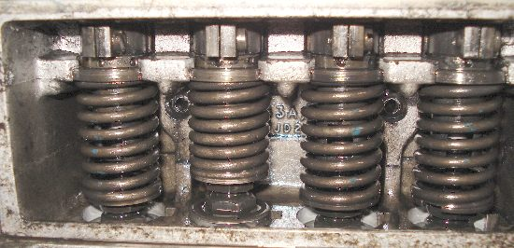
As number two tappet descends, (see photo above) start attempting to locate the timing hole in the flywheel using a parallel punch (or steel rod – but this must not bend) inserted through the dedicated hole in the rear flange of the cylinder block (see photo below.) A wise precaution is to tie the punch or steel rod with string to the disconnected battery cable’s terminal, as a reminder to remove the pin before starting the engine.)
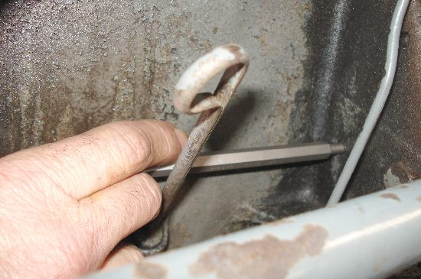
If you miss the flywheel’s hole, do not try to reverse the crankshaft. Instead, rotate the crankshaft almost two complete revolutions and again attempt to locate the hole. Push your punch into the hole to lock the engine in position (No. 1 piston will now be at 30° before top dead centre of its firing stroke: you know it will be on its firing stroke because you have just witnessed fuel pump tappet No. 2 descending and the two actions coincide.)
Once the flywheel has been locked by the punch in the timing hole, slacken all four fuel pipes between the fuel pump and the injectors at both ends. Also slacken the air pipe to the venturi.
You are about to disturb the setting of the fuel pump by a tangential distance that you will measure between the marks on its securing flange and the cylinder block. These marks are crude: better accuracy may be achieved if (using a straight edge and scriber) you scribe your own fine datum line across the two flanges adjacent to the marks provided and use your own marks thus created rather than the rather crude marks provided. You will need a digital calliper, dial calliper or vernier calliper to measure the amount by which you displace the matching marks (either your marks or the original marks) as accurately by eye as possible.
Now slacken (just) the three nuts holding the fuel injection pump to the cylinder block.
On tractors with engine numbers up to and including SA109123E (i.e. tractors built before mid-March 1956) retard the fuel pump (pull the top of the pump towards you) by 0.034 inch (“34 thou”) measured at the timing marks on the block and the pump (see photo below.)
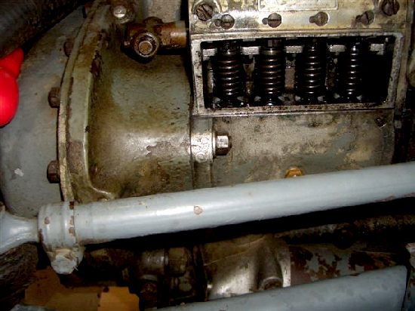
For tractors with engine numbers higher than SA109123E, advance the pump i.e. push the top of the pump towards the cylinder block by 0.068″ measured at the timing marks (see photo below.) Note that this method enables setting fuel pump timing on the later engines without a timing disc despite the workshop manual’s statement implying that these engines can be set only with a disc.
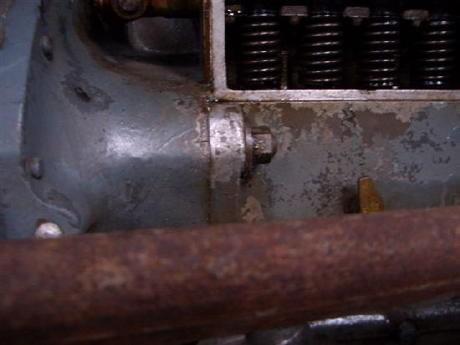
Re-tighten one of the nuts holding the injector pump to the block to temporarily secure the pump.
(Explanation: Trying to stop the flywheel with No. 1 piston at exactly 32° BTDC or 26° BTDC is virtually impossible. Therefore, by off-setting the pump to the position stated dependent on the engine number, you will be timing the pump with the engine at 30° BTDC and then returning the pump to its datum lines to achieve the desired 32° or 26° BTDC. This is more accurate than trying to guess the flywheel’s position and more practical than using a timing disc.)
Shut off the fuel supply at the fuel tank outlet.
Remove No.1 injector pipe, remove the delivery valve holder (see photo below)
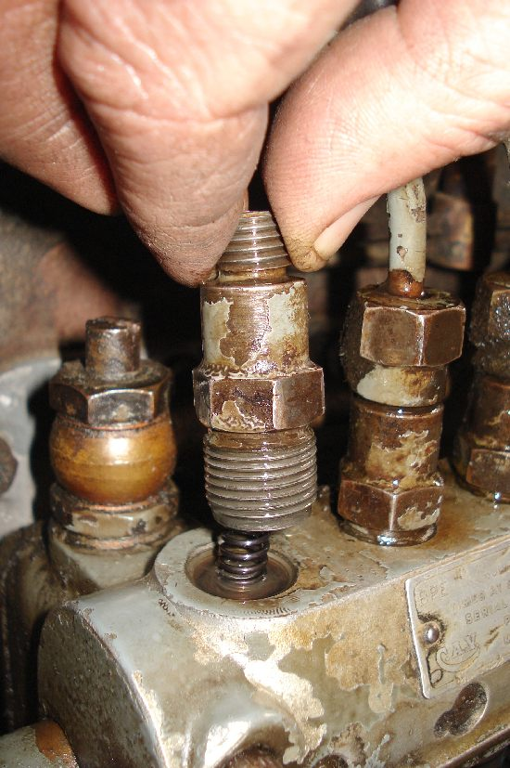
and then remove the spring and the valve within (see photo below)
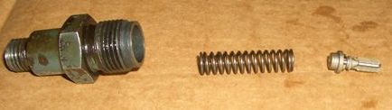
keeping these in a scrupulously clean, safe place. Replace the valve holder and attach the injector pipe as shown in the photo below. (Note: a special swan-necked pipe is not necessary; the existing injector pipe is ideal for this purpose.)
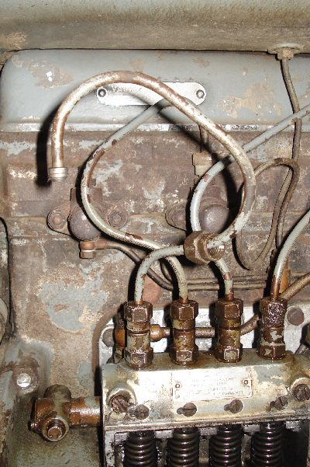
Remove the small inspection cover on the front of the timing case, remove the two nuts from the injector pump drive shaft and slide off the vernier coupling (see photo below.)
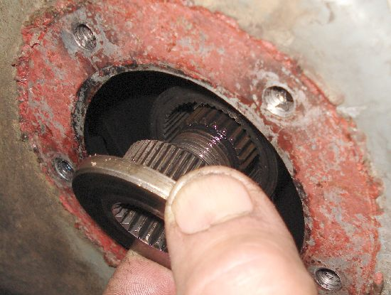
Open the fuel supply at the tank and check that the fuel cut-off is not in the stop position (pressing the excess fuel button is an alternative way to ensure fuel is available to the pump.)
If the special turning handle (FTB 32) for the fuel pump or a copy of it is unavailable, a Mole type self-grip wrench (ideally with curved jaws) can be used to turn the fuel pump provided that a piece of leather is used to protect the thread on the fuel pump’s shaft. The Mole grips must be carefully adjusted to grip lightly in order not to damage the thread and to reduce the likelihood of disturbing the set position of the shaft later whilst releasing the grips.
Slowly turn the pump drive shaft until the moment fuel stops flowing from No. 1 injector pipe. If the pump was too advanced (no fuel flow) it may be necessary to turn the pump’s shaft almost a complete turn to bring it to the desired position (watch the tappets – as number 2 descends then stops and number one just starts to rise, No 1 will be almost at the desired spill cut-off position). Once the cut-off point has been reached, very carefully remove the turning handle / wrench from the shaft ensuring that the shaft is not rotated even slightly and refit the vernier coupling. It is essential that neither the male nor female part of the drive is moved by the coupling as it is inserted. Care and patience is required for this: try to slide the vernier coupling gently into position, if it doesn’t slide in easily, withdraw it a little, turn the coupling one tooth and try again, continuing until you find a position where the splines and teeth engage freely. The photo below shows the splines and teeth that must not be moved whilst trying to find the position where the coupling will fit freely.
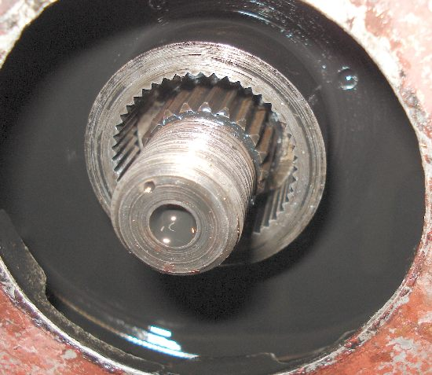
Fit one nut onto the coupling shaft to secure the vernier coupling. Withdraw the punch from the flywheel and rotate the crankshaft two turns, checking that the fuel stops flowing at exactly the same time as the timing holes line up (i.e. when you can again push the punch into the hole in the flywheel.) If not, remove the vernier coupling and re-set the timing. Once satisfied, tighten the coupling shaft’s nut and fit its locknut.
Now, re-position the injector pump to re-align the same timing marks on the cylinder block / fuel pump flange that you used earlier and tighten its three securing nuts. Then replace No.1 valve and spring, injector pipes, covers etc. and tighten unions as you bleed the fuel system.

